**Double linked list**

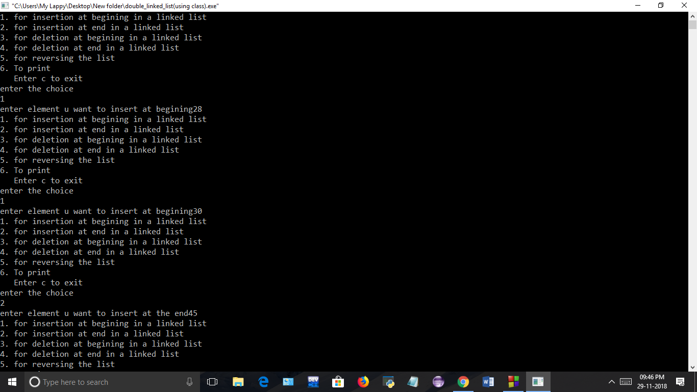

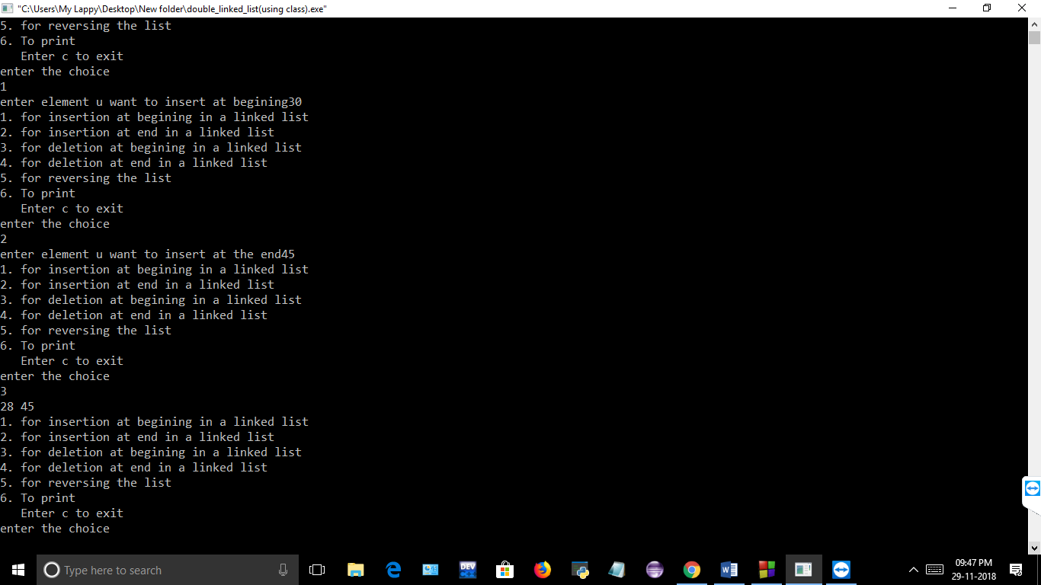

**Double linked list(using class and structure)**





**Double linked list(using class)**





**Double linked list(using structure in class)**



